**Creating Microservices for account and loan**

**Part-1 : Creating Account Microservice:**

**pom.xml:**

<?xml version="1.0" encoding="UTF-8"?>

<project xmlns="http://maven.apache.org/POM/4.0.0" xmlns:xsi="http://www.w3.org/2001/XMLSchema-instance"

xsi:schemaLocation="http://maven.apache.org/POM/4.0.0 https://maven.apache.org/xsd/maven-4.0.0.xsd">

<modelVersion>4.0.0</modelVersion>

<parent>

<groupId>org.springframework.boot</groupId>

<artifactId>spring-boot-starter-parent</artifactId>

<version>3.5.3</version>

<relativePath/> <!-- lookup parent from repository -->

</parent>

<groupId>com.cognizant</groupId>

<artifactId>account</artifactId>

<version>0.0.1-SNAPSHOT</version>

<name>account</name>

<description>Demo project for Spring Boot</description>

<url/>

<licenses>

<license/>

</licenses>

<developers>

<developer/>

</developers>

<scm>

<connection/>

<developerConnection/>

<tag/>

<url/>

</scm>

<properties>

<java.version>21</java.version>

</properties>

<dependencies>

<dependency>

<groupId>org.springframework.boot</groupId>

<artifactId>spring-boot-starter-web</artifactId>

</dependency>

<dependency>

<groupId>org.springframework.boot</groupId>

<artifactId>spring-boot-devtools</artifactId>

<scope>runtime</scope>

<optional>true</optional>

</dependency>

<dependency>

<groupId>org.springframework.boot</groupId>

<artifactId>spring-boot-starter-test</artifactId>

<scope>test</scope>

</dependency>

</dependencies>

<build>

<plugins>

<plugin>

<groupId>org.springframework.boot</groupId>

<artifactId>spring-boot-maven-plugin</artifactId>

</plugin>

</plugins>

</build>

</project>

**AccountController.java**

**package** com.cognizant.account;

**import** org.springframework.web.bind.annotation.*;

@RestController

**public** **class** AccountController {

@GetMapping("/accounts/{number}")

**public** Account getAccount(@PathVariable String number) {

**return** **new** Account(number, "savings", 234343);

}

**class** Account {

**private** String number;

**private** String type;

**private** **int** balance;

**public** Account(String number, String type, **int** balance) {

**this**.number = number;

**this**.type = type;

**this**.balance = balance;

}

**public** String getNumber() { **return** number; }

**public** String getType() { **return** type; }

**public** **int** getBalance() { **return** balance; }

}

}

**AccountApplication.java:**

**package** com.cognizant.account;

**import** org.springframework.boot.SpringApplication;

**import** org.springframework.boot.autoconfigure.SpringBootApplication;

@SpringBootApplication

**public class** AccountApplication {

**public static void** main(String[] args) {

SpringApplication.run(AccountApplication.class, args);

}

}

**application.properties:**

spring.application.name = account

server.port = 8080

**Output:**

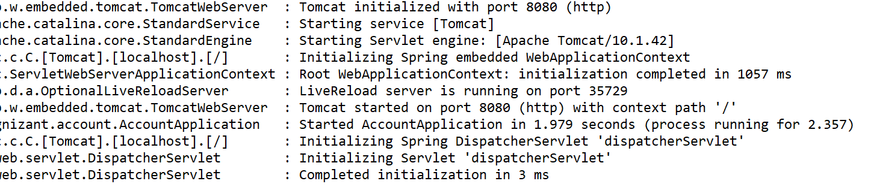

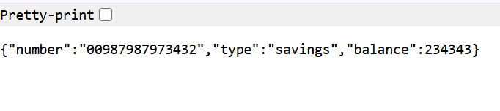



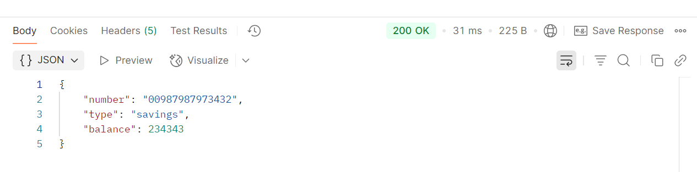

**Part-2:Creating Loan microservice:**

**Pom.xml:**

<?xml version="1.0" encoding="UTF-8"?>

<project xmlns="http://maven.apache.org/POM/4.0.0" xmlns:xsi="http://www.w3.org/2001/XMLSchema-instance"

xsi:schemaLocation="http://maven.apache.org/POM/4.0.0 https://maven.apache.org/xsd/maven-4.0.0.xsd">

<modelVersion>4.0.0</modelVersion>

<parent>

<groupId>org.springframework.boot</groupId>

<artifactId>spring-boot-starter-parent</artifactId>

<version>3.5.3</version>

<relativePath/> <!-- lookup parent from repository -->

</parent>

<groupId>com.cognizant</groupId>

<artifactId>loan</artifactId>

<version>0.0.1-SNAPSHOT</version>

<name>loan</name>

<description>Demo project for Spring Boot</description>

<url/>

<licenses>

<license/>

</licenses>

<developers>

<developer/>

</developers>

<scm>

<connection/>

<developerConnection/>

<tag/>

<url/>

</scm>

<properties>

<java.version>21</java.version>

</properties>

<dependencies>

<dependency>

<groupId>org.springframework.boot</groupId>

<artifactId>spring-boot-starter-web</artifactId>

</dependency>

<dependency>

<groupId>org.springframework.boot</groupId>

<artifactId>spring-boot-devtools</artifactId>

<scope>runtime</scope>

<optional>true</optional>

</dependency>

<dependency>

<groupId>org.springframework.boot</groupId>

<artifactId>spring-boot-starter-test</artifactId>

<scope>test</scope>

</dependency>

</dependencies>

<build>

<plugins>

<plugin>

<groupId>org.springframework.boot</groupId>

<artifactId>spring-boot-maven-plugin</artifactId>

</plugin>

</plugins>

</build>

</project>

**Loan.java:**

**package** com.cognizant.loan;

**import** com.fasterxml.jackson.annotation.JsonProperty;

**import** com.fasterxml.jackson.annotation.JsonPropertyOrder;

@JsonPropertyOrder({ "number", "type", "loan", "emi", "tenure" })

**public** **class** Loan {

**private** String number;

**private** String type;

@JsonProperty("loan")

**private** **int** totalLoan;

**private** **int** emi;

**private** **int** tenure;

**public** Loan(String number, String type, **int** totalLoan, **int** emi, **int** tenure) {

**this**.number = number;

**this**.type = type;

**this**.totalLoan = totalLoan;

**this**.emi = emi;

**this**.tenure = tenure;

}

**public** String getNumber() {

**return** number;

}

**public** String getType() {

**return** type;

}

**public** **int** getTotalLoan() {

**return** totalLoan;

}

**public** **int** getEmi() {

**return** emi;

}

**public** **int** getTenure() {

**return** tenure;

}

}

**LoanController.java:**

**package** com.cognizant.loan;

**import** org.springframework.web.bind.annotation.*;

@RestController

@RequestMapping("/loans")

**public** **class** LoanController {

@GetMapping("/{number}")

**public** Loan getLoan(@PathVariable String number) {

**return** **new** Loan(number, "car", 400000, 3258, 18);

}

}

**LoanApplication.java:**

**package** com.cognizant.loan;

**import** org.springframework.boot.SpringApplication;

**import** org.springframework.boot.autoconfigure.SpringBootApplication;

@SpringBootApplication

**public class** LoanApplication {

**public static void** main(String[] args) {

SpringApplication.run(LoanApplication.class, args);

}

}

**application.properties:**

spring.application.name=loan

server.port=8081

**Output:**

